**USER MANAGEMENT – TASK**

**ADDING GROUP FOR CSK:**

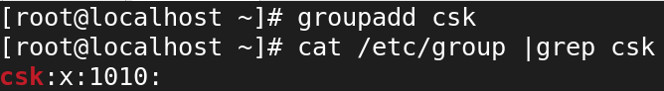

**ADDING GROUP FOR RCB:**

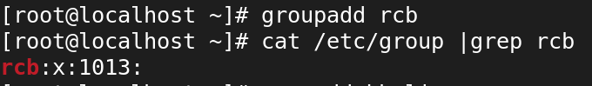

**CREATING USERS FOR GROUP[CSK]:**



* **etc/passwd 🡪** information about all users on the system.



**CREATING USERS FOR GROUP[RCB]:**

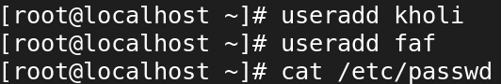

**ADDING USERS DHONI RAINA TO CSK:**

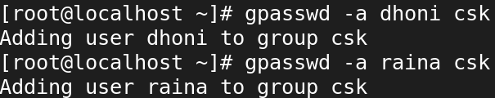

**CHECK USERS ADDED TO GROUP[CSK]:**



**ADDING USERS KHOLI FAF TO RCB:**

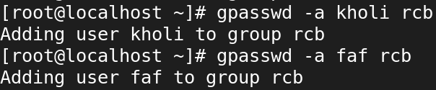

**CHECK USERS ADDED TO GROUP[RCB]:**



**CREATING DIR CRICKET IN /:**



**CREATING DIR KINGS CHALLENGERS INSIDE THE CRICKET DIRECTORY:**

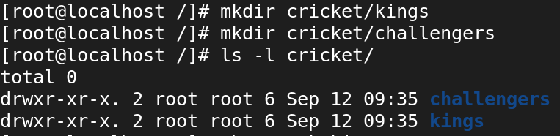

**CHANGE FULL PERMISSION FOR OTHER TO CRICKET DIRECTORY:**

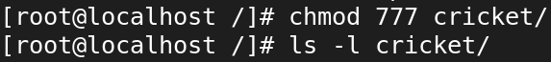

**SUB DIRECTORIES CHANGE GROUP AS CSK FOR KINGS AND CHANGE GROUP AS RCB FOR CHALLENGERS:**

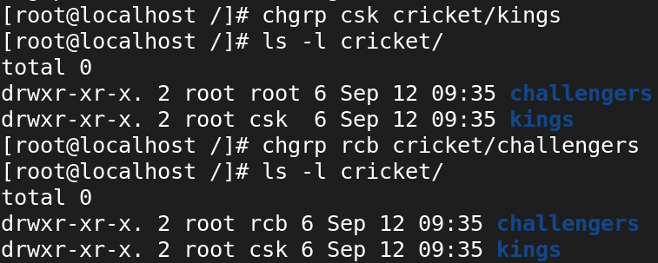

**FULL PERMISSION FOR THE GROUP TO KINGS DIRECTORY AND ALSO GIVE SAME FOR CHALLENGERS DIRECTORY:**

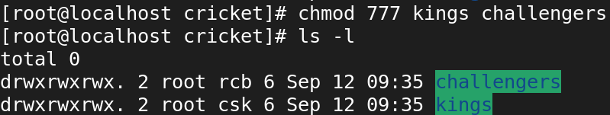

**REMOVE ALL PERMISSION FOR OTHERS FROM BOTH THE KINGS AND CHALLENGERS DIRECTORY:**

